**A**

**PROJECT REPORT**

ON

**CLOTHIFY**

Submitted in partial fulfilment for the award of

**Post Graduate Diploma in Advance Computing**

**(PG-DAC) from**

**INSTITUTE OF EMERGING TECHNOLOGIES**

**Authorized Training Centre**



**Under the Guidance of**

**Mrs. Savita Vaidya**

**BY**

Atharva Malode 230945920007

Chitra Gour 230945920017

Ganesh Mundada 230945920026

Rutvik Patil 230945920065

Pratik Khond 230945920074



**CERTIFICATE**

This is to certify that the project report entitled **Clothify** is a bonfire work carried out by **Pratik Khond, Chitra Gour, Atharva Malode, Ganesh Mundada, Rutvik Patil,** andsubmitted in partial fulfilment ofthe requirement for the C-DAC ACTS, DAC course in Institute of Emerging Technology in the batch of September 2023.

**Course Coordinator** **External Examiner**

Mr. Manoj Deshmukh Mrs. Sampada Tarare

**ACKNOWLEDGEMENT**

This project **Clothify** was a great learning experience for us and we are submitting this work to Advanced Computing Training School (CDAC).

We are very glad to mention **Mrs. Savita Vaidya**  for her valuableguidance to work on this project. Her guidance and support helped us to overcome various obstacles and intricacies during the course of project work.

Our most heart full thanks goes to **Mr. Sangram Patil** **(Director, IET)** who gave all the required support and kind coordination to provide all the necessities like required hardware , internet facility and extra lab hours to complete the project and throughout the course up to the last day here in C-DAC ACTS, Pune.

Name PRN Signature of student

Atharva Malode 230945920007

Chitra Gour 230945920017

Ganesh Mundada 230945920026

Rutvik Patil 230945920065

Pratik Khond 230945920074

**Abstract**

The aim of this project is to create a platform that incentivizes sustainable consumer behaviour by offering coupons in exchange for old clothes. The platform serves as a bridge between consumers seeking to dispose of unused garments and retailers interested in promoting recycling and responsible consumption. Through a user-friendly website, individuals can submit details of their old clothing items in exchange for coupons redeemable at participating retailers. The system employs a transparent and efficient process to verify submissions and issue digital coupons, thereby encouraging users to recycle and reduce textile waste. This report outlines the design, development, and implementation of the platform, highlighting its potential impact on promoting sustainability in the fashion industry.

**Index**

|  |  |  |
| --- | --- | --- |
| **Sr. No.** | **Title** | **Page No.** |
| **1** | Introduction | 6-7 |
| **2** | Problem Definition & Scope | 8-13 |
| **2.1** | Problem Definition | 8-9 |
| **2.2** | Goals & Objectives | 10-11 |
| **2.3** | Major Constraints & Outcomes | 12-13 |
| **3** | Software Requirement Specification | 14 |
| **3.1** | Purposed System | 15 |
| **3.2** | Scope | 15 |
| **4** | System Modules | 16 |
| **5** | Performance-Requirements | 16 |
| **5.1** | H/W Requirements & S/W Requirements | 16 |
| **6** | UML Diagram | 17 |
| **6.1** | DFD | 18 |
| **6.2** | ERD | 18 |
| **6.3** | Use case diagram | 18 |
| **6.4** | Class Diagram | 19 |
| **6.5** | Deployment diagram | 20 |
| **6.6** | System Architecture | 20 |
| **7** | Screenshots | 21 |
| **8** | References | 22 |

**1. Introduction:**

At Clothify, we believe in the power of sustainable fashion and responsible consumption. Our platform serves as a bridge between conscious consumers, environmentally-friendly brands, and the recycling ecosystem. With a focus on reducing textile waste and promoting circular fashion practices, we offer a convenient solution for individuals to recycle their clothes while earning valuable coupons from leading brands. Our process is simple: our delivery team collects your clothes, we assess their condition, and in return, you receive exclusive coupons to use towards your next purchase.

By partnering with a diverse range of brands committed to sustainability, we aim to incentivize and reward our users for their contribution to a greener future. Together, let's embrace a more sustainable approach to fashion and make a positive impact on our planet. In a world where fast fashion dominates, we're on a mission to revolutionize the way we think about clothing. At Clothify, we're committed to promoting a circular economy by extending the lifecycle of clothing and reducing textile waste.

**2. Problem Definition and Scope:**

**2.1 Problem Statement:-**

Despite growing environmental concerns and the increasing popularity of sustainable fashion, many individuals still struggle to find accessible and incentivized avenues to responsibly dispose of their old clothes while obtaining affordable options to update their wardrobe. This gap presents an opportunity to develop a platform that facilitates the exchange of old clothes for coupons usable within a clothing brand, thereby promoting sustainability, reducing textile waste, and fostering a more circular approach to fashion consumption.

**1.Environmental Impact:** Clothing disposal contributes to environmental pollution, as textiles often end up in landfills where they release greenhouse gases and leach harmful chemicals into the soil and waterways. Synthetic fibers, such as polyester and nylon, can take hundreds of years to decompose.

**2.Waste Generation:** The fashion industry produces vast amounts of waste, with millions of tons of clothing discarded each year globally. Fast fashion culture exacerbates this problem by promoting frequent purchasing and disposal of clothing items.

**3.Resource Depletion:** The production of textiles consumes significant resources, including water, energy, and raw materials. Disposing of clothing prematurely wastes these resources, contributing to resource depletion and environmental degradation.

**4.Limited Recycling Technologies:** Traditional textile recycling methods often result in downcycling, where the quality of recycled fibers degrades over time. Developing and scaling advanced recycling technologies capable of producing high-quality recycled fibers is a significant challenge.

**5.Chemical and Water Usage:** Conventional textile recycling processes may involve the use of chemicals and large amounts of water, leading to environmental pollution and resource depletion. Finding more sustainable and eco-friendly recycling methods is essential.

**6.Fast Fashion Culture:** The proliferation of fast fashion encourages rapid consumption and disposal of clothing, contributing to the growing textile waste proble

**2.2** **Goals & Objectives:-**

**Goals**

**1.Sustainability Promotion:**

Encouraging consumers to recycle and exchange old clothes promotes sustainable practices by reducing textile waste and promoting the reuse of clothing items.

**2.Customer Engagement:**

Creating an interactive platform where customers can exchange their old clothes for coupons can help in engaging customers and building a loyal user base.

**3.Brand Partnerships:**

Building partnerships with various brands to offer coupons in exchange for old clothes can help in expanding the customer base and providing value-added services to users.

**4.Revenue Generation:**

While the primary focus might be on sustainability and customer engagement, such a platform can also generate revenue through various means such as charging a fee for the exchange service, affiliate marketing with partner brands, or selling refurbished clothes.

**5.Scalability and Expansion:**

Planning for scalability and potential expansion into new markets or offering additional services related to sustainable fashion can be long-term goals for the platform.

**6.Customer Satisfaction:**

Ensuring a seamless and satisfactory experience for users, including easy exchange processes, timely delivery of coupons, and responsive customer support, is crucial for retaining customers and building positive brand perception.

**7.Continuous Improvement:**

Striving for continuous improvement by gathering feedback from users, monitoring industry trends, and adapting strategies to meet evolving customer needs and market dynamics is essential for the long-term success of the platform.

**Objectives**

**1.Develop a User-Friendly Interface:**

Design and implement an intuitive and user-friendly interface for customers to easily navigate and place orders.

**2.Automate Workflows:**

Streamline and automate the orders and coupons allotment workflows to reduce manual intervention and enhance efficiency.

**3.Promote Environmental Sustainability:**

The primary objective is to reduce textile waste and promote sustainable practices within the fashion industry by encouraging consumers to recycle their old clothes rather than disposing of them.

**4.Collaborate and Partner:**

Forge partnerships with environmental organizations, fashion industry stakeholders, government agencies, and other relevant entities to amplify the platform's reach, influence, and impact on promoting sustainable clothing practices.

**2.3** **Major Constraints & Outcome:**-

**Major Constraints:**

**1.Technical Limitations:**

Adhere to technical constraints such as platform compatibility, security measures, and scalability to ensure the smooth functioning of the online exchange platform.

**2. Resource Availability:**

Work within budgetary constraints and available resources for website development, marketing efforts, and operational expenses.

**3. Logistical Challenges:**

Address logistical constraints related to the collection, sorting, and processing of old clothes, including transportation and storage considerations

**Potential Outcomes:**

**1.Increased Participation:**

Achieve a significant increase in the number of users participating in the clothing exchange program, indicating a positive response to the initiative.

**2. Textile Waste Reduction:**

Measure a tangible reduction in textile waste through the collection and recycling of old clothes, contributing to environmental sustainability goals.

**3. Community Engagement:**

Foster a vibrant online community centered around sustainable fashion practices, with active participation in discussions, events, and feedback mechanisms.

**4. Brand Awareness and Loyalty:**

Improve brand awareness and loyalty by establishing the clothing brand as a leader in sustainable fashion and a champion of environmental responsibility.

**5. Measurable Impact:**

Quantify the environmental impact of the project through metrics such as the volume of clothes recycled, carbon emissions saved, and landfill diversion rates

**3. Software Requirements & Specifications:**

**3.1 Title:**

System Requirement Specifications for Clothify.

**3.2 Scope:**

1. **Platform Development:**

This includes the creation and maintenance of the e-commerce website or application where users can register, browse available coupons, exchange old clothes, and track their transactions.

1. **Sustainability Initiatives:**

Implementing mechanisms for collecting, sorting, and recycling old clothes in an environmentally responsible manner is a significant aspect. This might involve partnerships with recycling facilities or sustainable fashion organizations.

1. **Brand Partnerships:**

Establishing relationships with brands willing to participate in the coupon exchange program, negotiating terms, and integrating their coupons into the platform.

1. **User Experience:**

Designing an intuitive and user-friendly interface for easy navigation, smooth exchange processes, and efficient communication with users. This includes incorporating features like search functionality, filtering options, and secure payment gateways.

1. **Marketing and Promotion:**

Developing strategies to attract users to the platform, raise awareness about the benefits of clothing exchange, and promote brand partnerships through various channels such as social media, email campaigns, and influencer collaborations.

1. **Logistics and Operations:**

Managing logistics for collecting old clothes from users, transporting them to recycling or processing facilities, and distributing coupons to users in a timely manner. This also involves inventory management to ensure an adequate supply of coupons from partner brands.

1. **Data Management:**

Implementing systems for collecting and analysing data on user behaviour, transaction history, and market trends to inform decision-making, improve operational efficiency, and personalize user experiences.

1. **Customer Support:**

Providing responsive customer support to address user inquiries, resolve issues, and ensure a positive overall experience. This may include offering multiple channels for communication such as live chat, email, and phone support.

**3.3 Functional Requirements:**

1.) The system will be accesible for the registered users and admin.

2.) The system will provide the role wise dashboard navigation.

3.) The user will be accessible for viewing their personal data.

4.) The admin will be accesible for viewing the business data.

**User:**

Only registered users can log into the system.

Users can modify their profile.

Registered users will be able to get customer support.

Users can access their own details only.

Users can see their history of orders and clothes exchanges carried out by the company.

Users can see the status of their clothes sent for exchange and the probable discount on the former.

Users can see their collected points for their exchanges in that particular year.

**Admin:**

Admin will be responsible for coordinating activities, managing schedules

and ensuring deliverables are completed on time.

Dashboard will provide information using data presentation

which will be accesible to the admin.

**Pickup and Quality Control:**

Only registered consignees can log into the system.

Consignees can modify their profile.

Registered consignees will be able to get support when required.

Consignees can access their own details only.

Consignees can see their revenue for their particular completed exchanges for every month.

Quality control person will update the report of received clothes to the portal.

**3.4 Non Functional Requirements**

**Security:**

Only Admin will see all records.

Only Admin should be able to modify their own personal details.

User can log in with their user ID and password. Admin and user can access their details.

No user can access other users' details except admin.

System will provide access to the content, operations using Role-based security (Authorization) (Permissions based on Role).

**Reliability:**

The system will back up user data regularly and recover it in a short time to keep the system operational.

Continuous updates are maintained through email, and continuous administration is done to keep contact with users.

During peak hours, the system will maintain the same user experience by managing load balancing.

**Availability:**

24*7 available

**Portability:**

The system will provide a portable User Interface (HTML, CSS, React) through which users will access the web application.

**Accesibility:**

Only registered users will be able to log in after authentication.

**Durability:**

The system will maintain users' detail.

The system will implement backup and recovery for retaining users' data and their Business data over time.

**4. System Modules:**

**1.User Management:**

* User Registration : allows customers to create account and maintain their profile dashboard.
* User Login : allows user to login using his respective credentials like username and password.

**2.Place Order:**

* Place order for getting brand coupons
* Orders are placed based on the required details like pickup date,description of clothes provided by the registered user.

**3.Pickup Person Login:**

* This module manages all pickup person login which validates a pickup person as an authorised pickup person who allocates coupons and accepts orders..

**4.Allot Coupons:**

* This module allows to allot coupons with its respective validity to the user once order is placed.

**5.Admin Dashboard:**

* Order Details : consists of order details of various customers who have placed orders.
* Feedback of pickup person : admin reviews the feedbacks of pickup persons given by registered users after pickup has been successfully done.

**5. Performance Requirements:**

Performance requirements for an Clothify application ensure that the platform functions effectively, efficiently, and reliably. These requirements are crucial to deliver a seamless user experience and achieve the goals of the application.

**5.1 H/W Requirements:**

1. Intel i3 processor 3rd generation or later / AMD Ryzen 200 2nd generation or later

2. 4GB RAM.

3. Windows 7 Home edition or later.

4. 200 GB data HDD Space

5. Data Connection 200 kbps

**5.2 S/W Requirements:**

1. Eclipse 4.7

2. MySQL 5.8 with Workbench 8.0

3. Google Chrome version 119

4. Apache Tomcat Server 9.0

5. Maven Dependencies

6. Visual Studio Code

**TECH-STACK**

• Front End Technologies: 1. React.js

2. Bootstrap

3. HTML5

4. CSS

5. JavaScript

• Backend Technologies: 1. Java

2. Spring Boot

3. Hibernate

4. MySQL

**6. UML DIAGRAMS**

* 1. **Data Flow Diagram:**

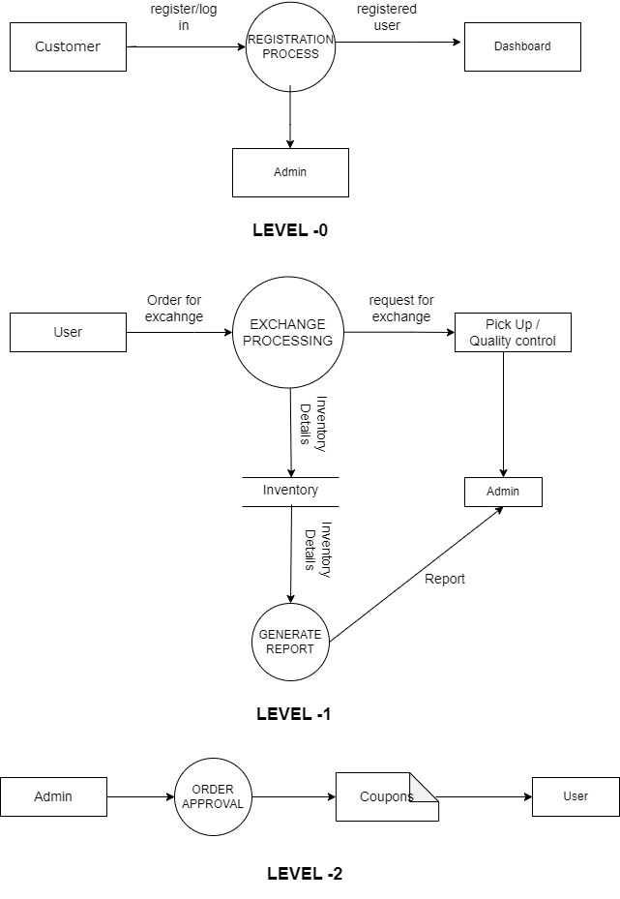

* 1. **Entity Relationship Diagram:**

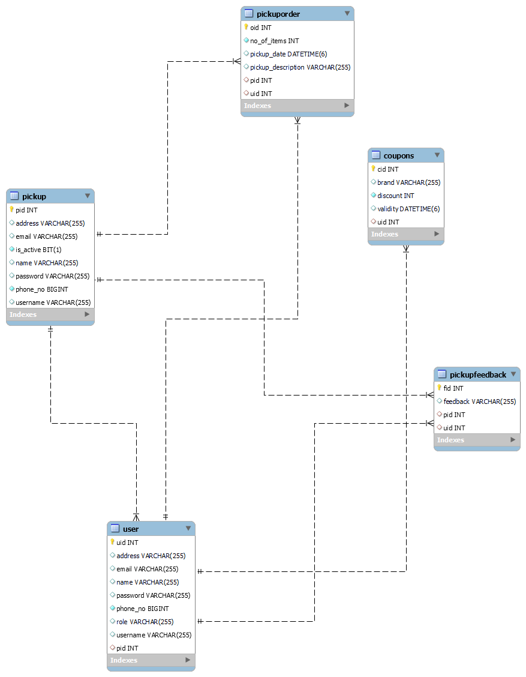

**6.3 Use Case Diagram:**

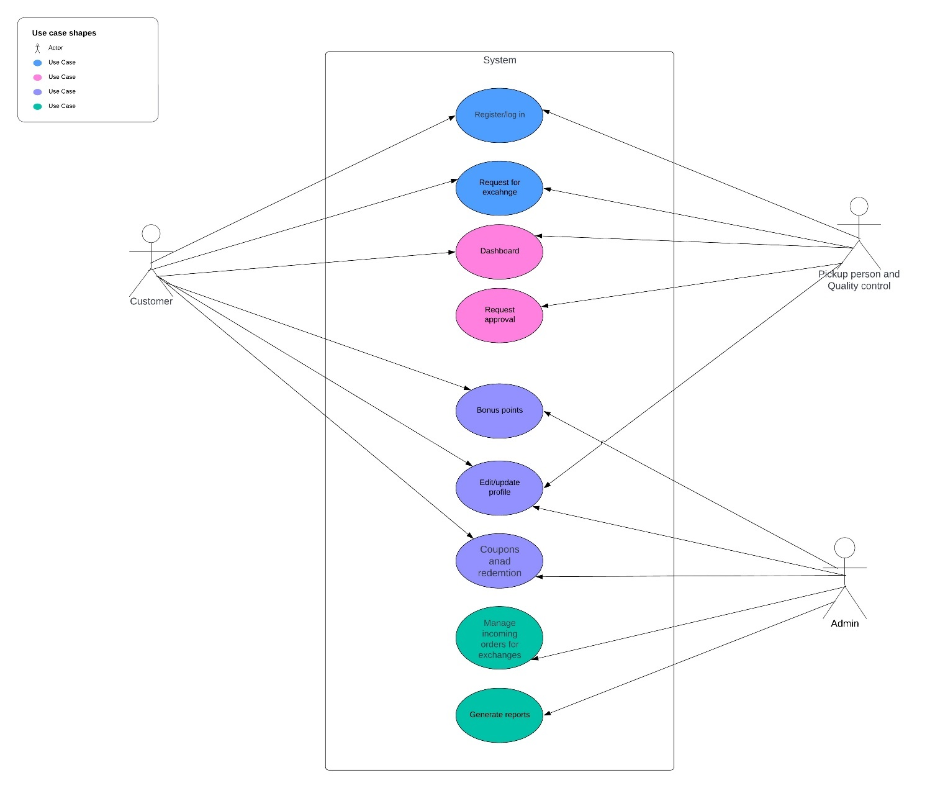

**6.4 Class Diagram:**

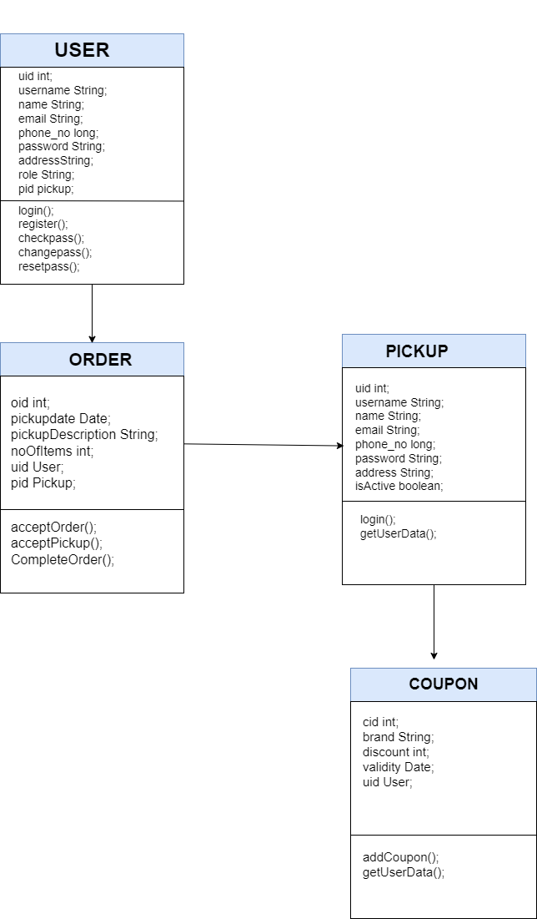

* 1. **Deployment Diagram:**

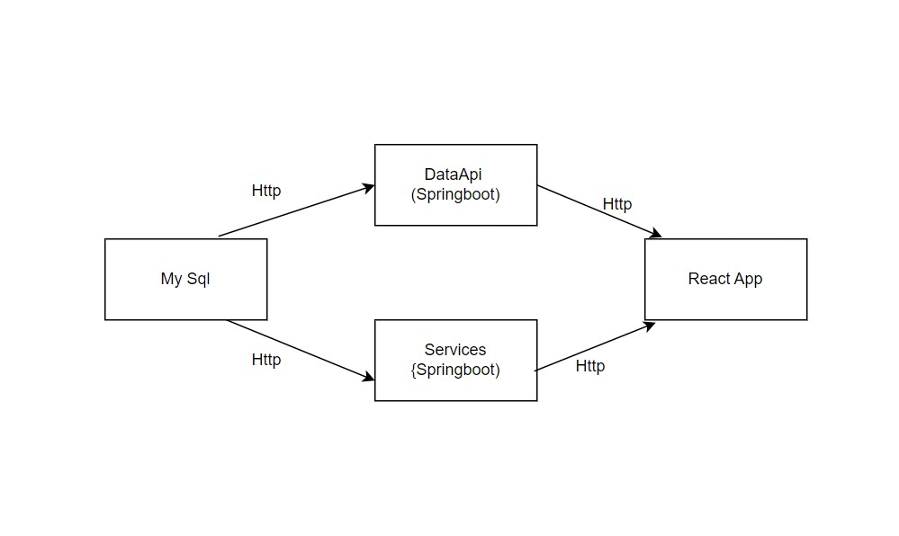

**7. Screenshots:**

Home page of the website :

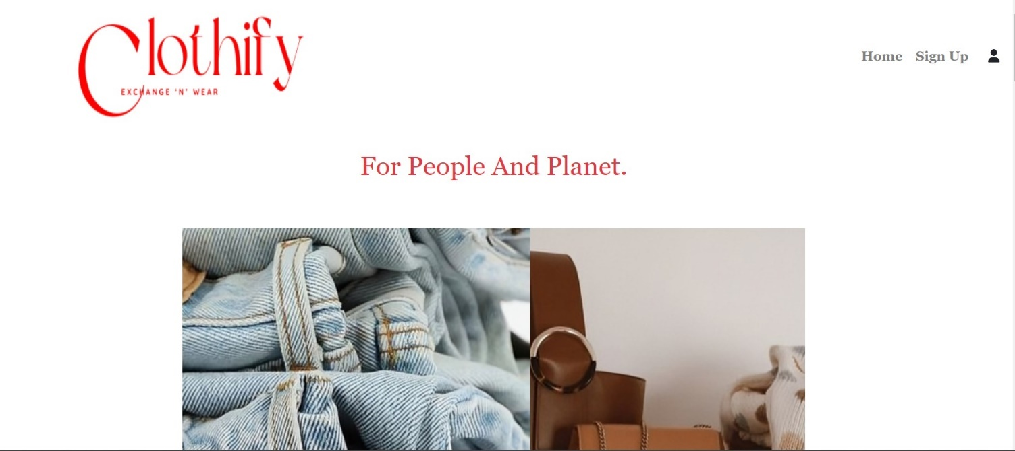

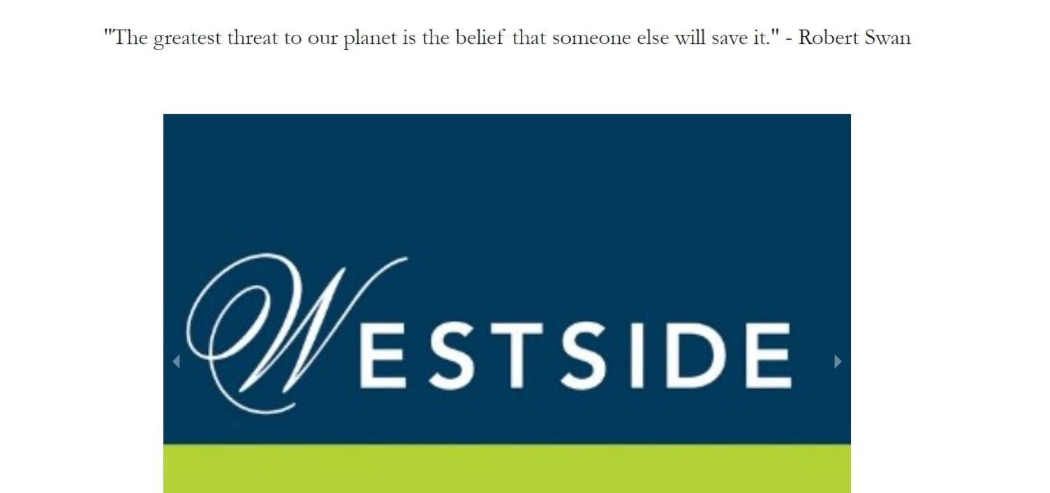

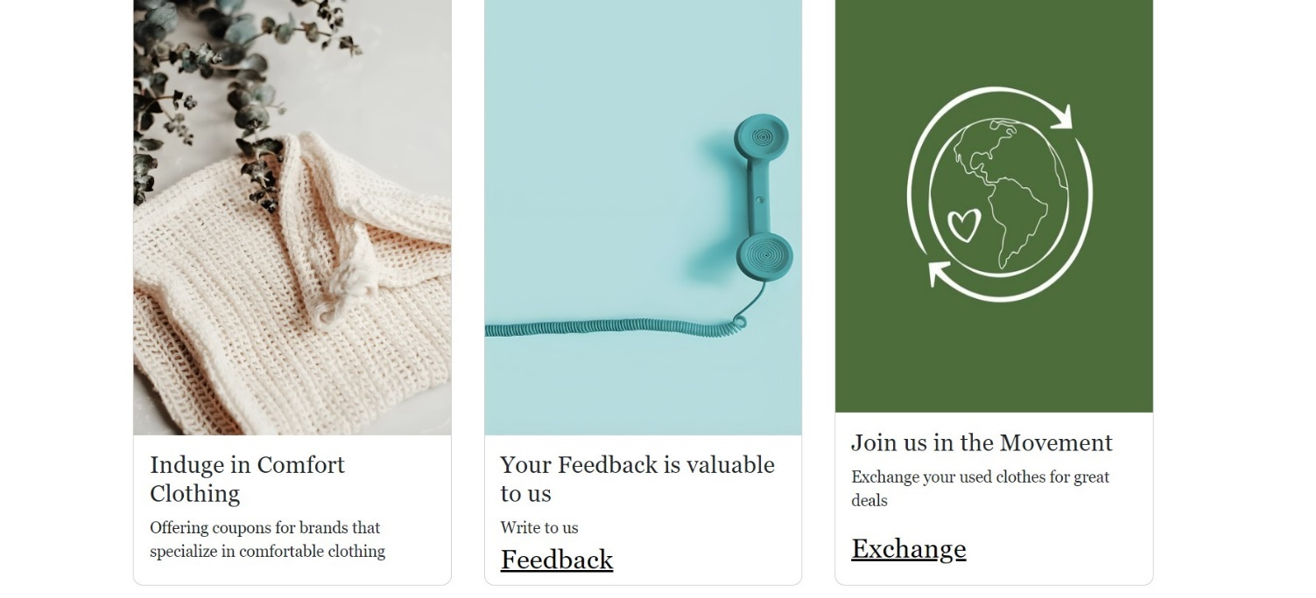

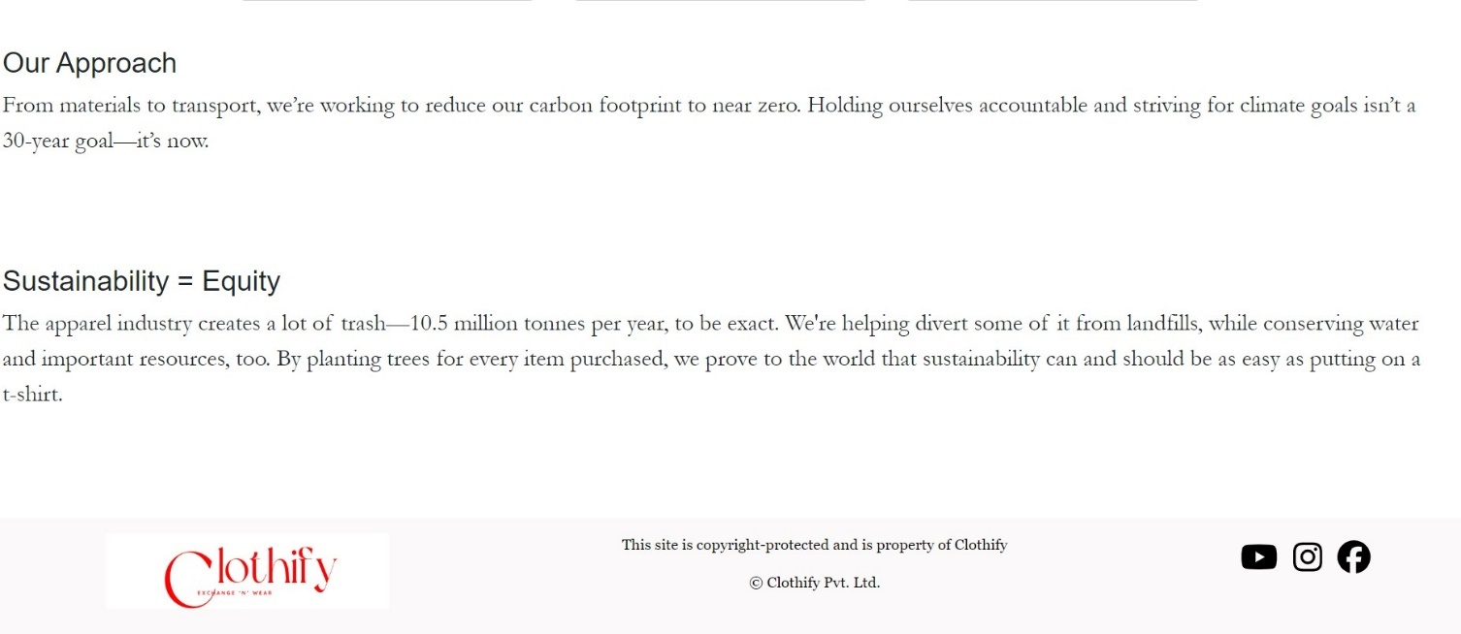

Registration page

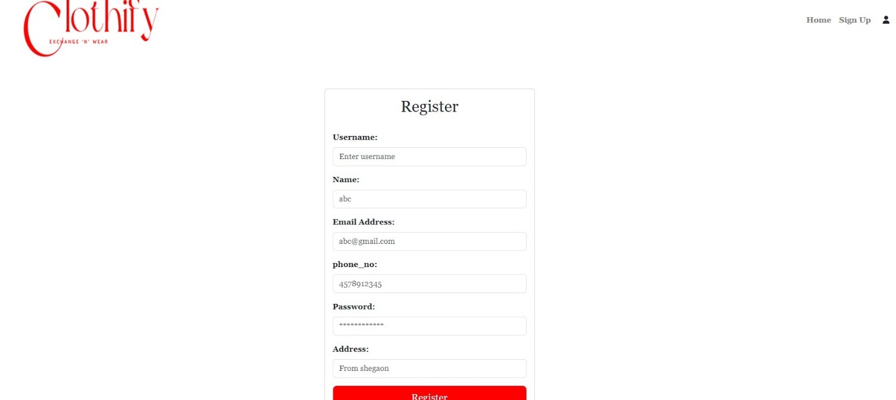

Login page

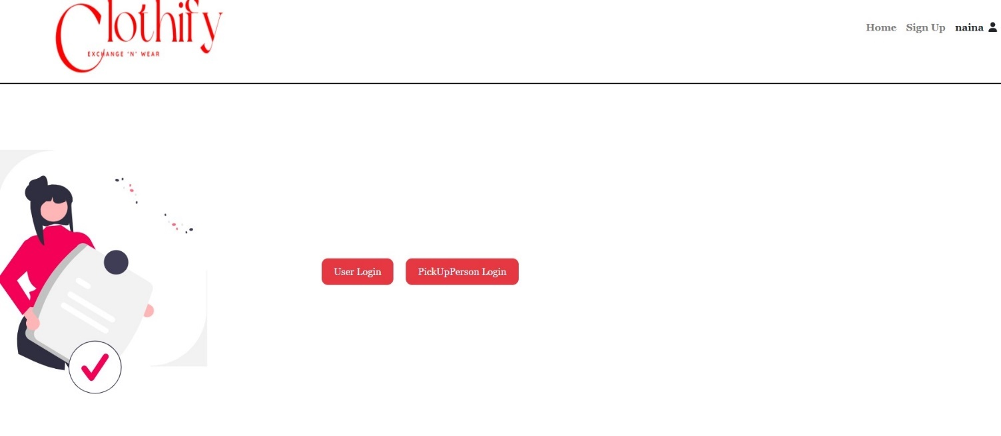

User login page

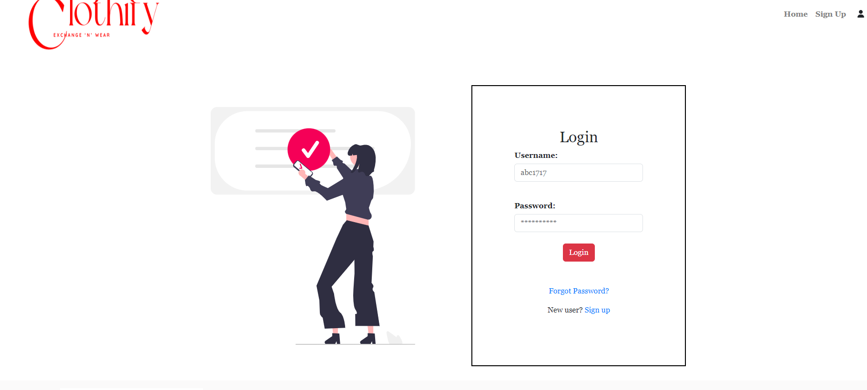

Pick Up person Login page

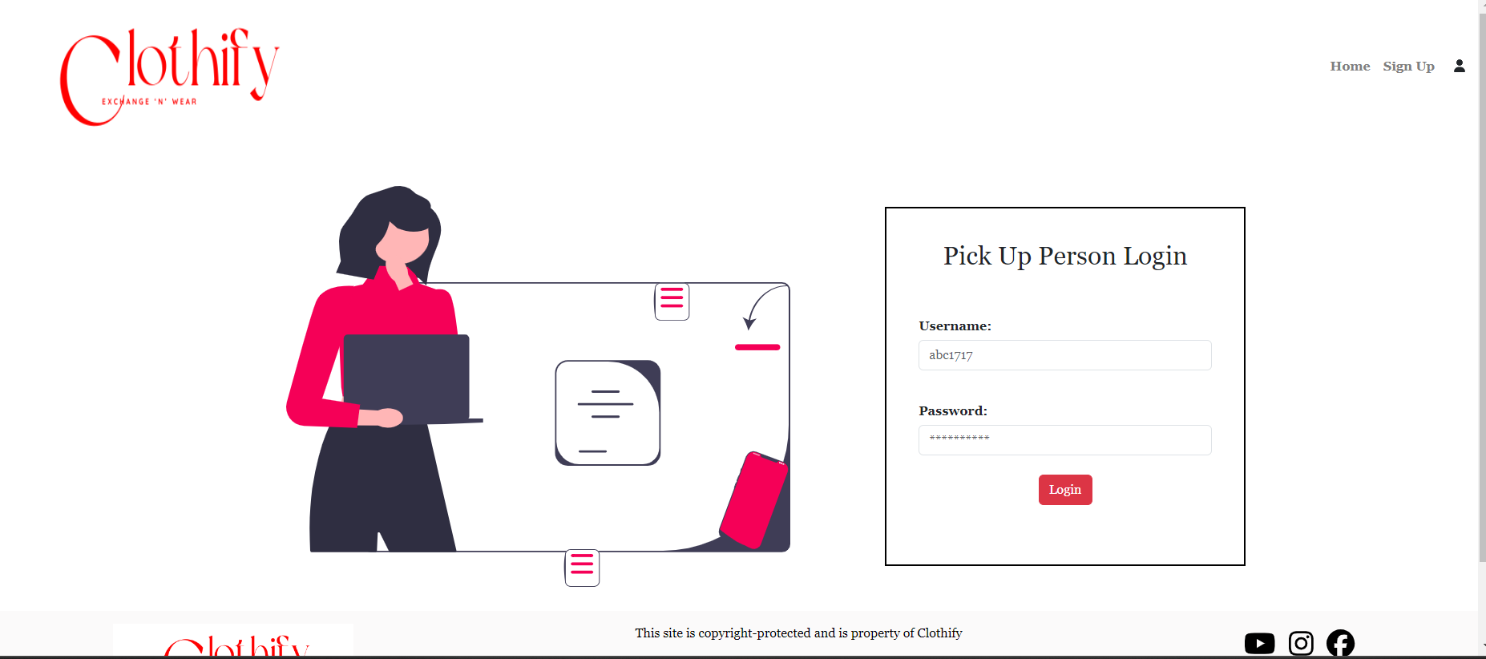

User Profile page

With “Exchange Now” and “View Orders” buttons

& has the “Alloted Coupons” for the user

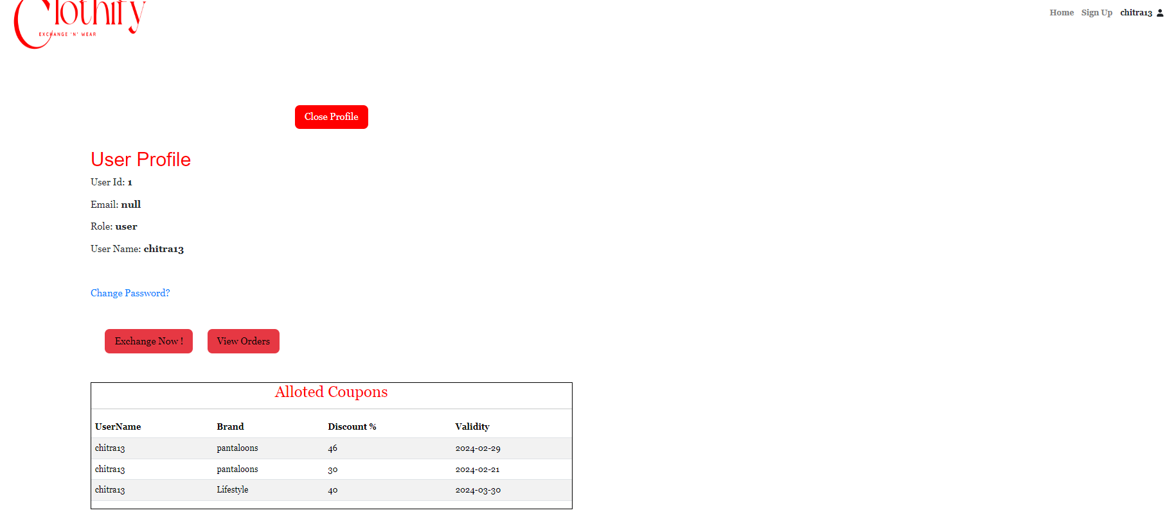

Order now page

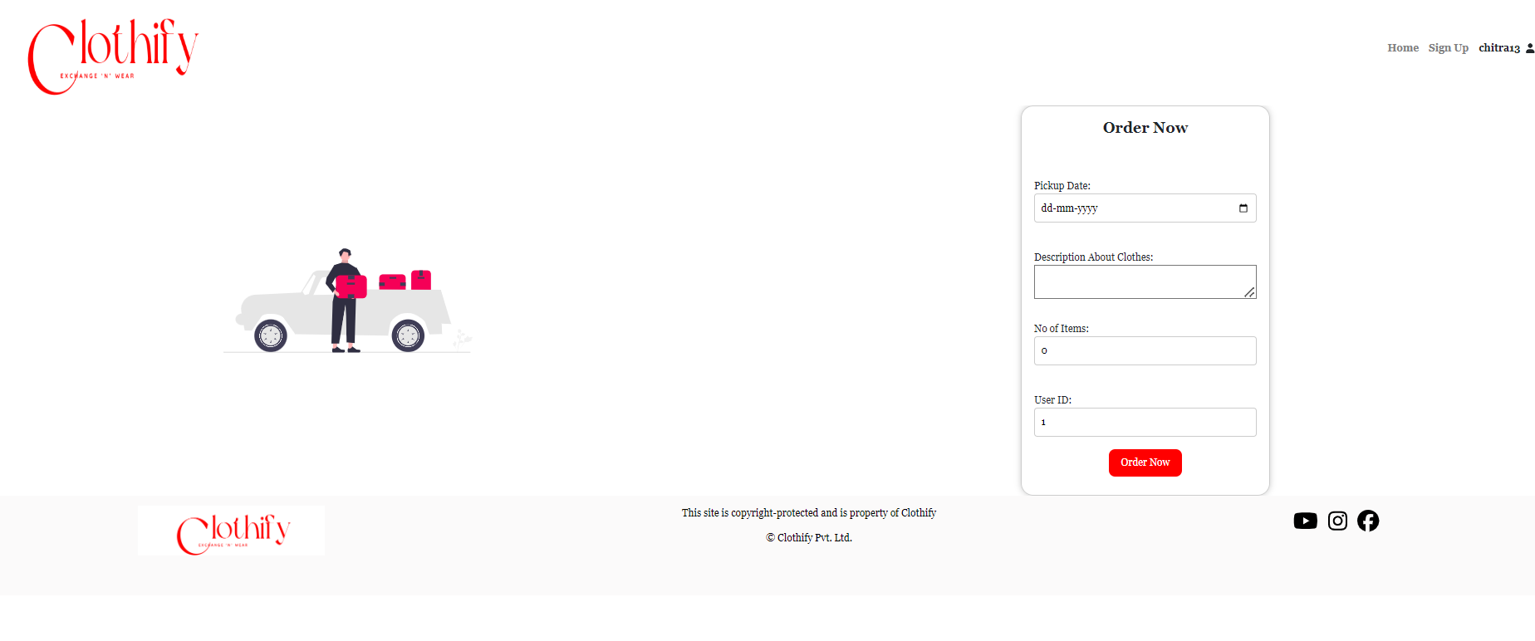

Placed orders page

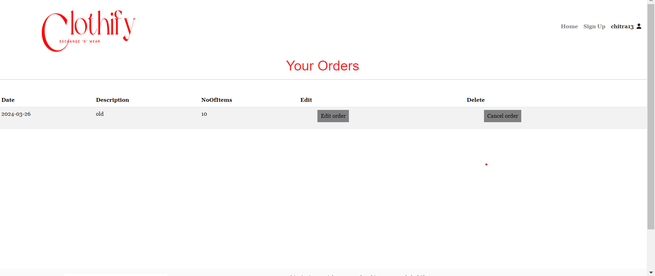

Sign Out page

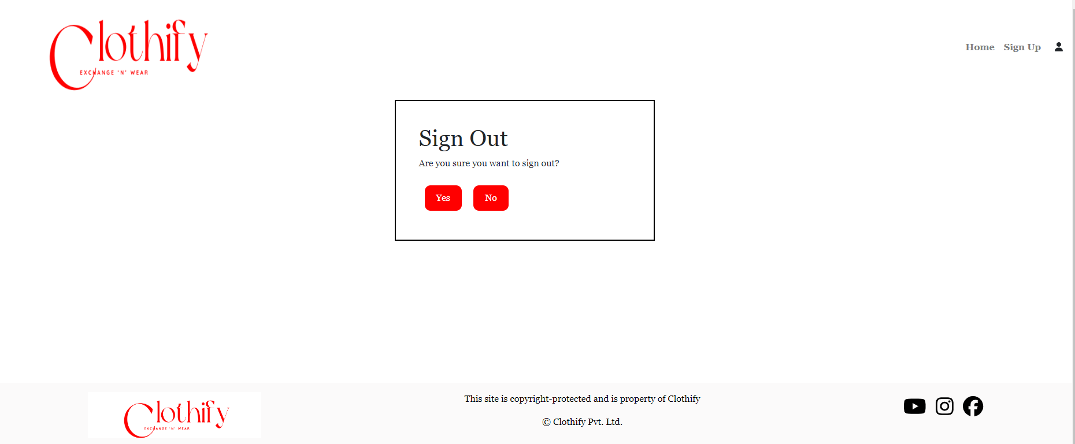

Authorised Pickup person page

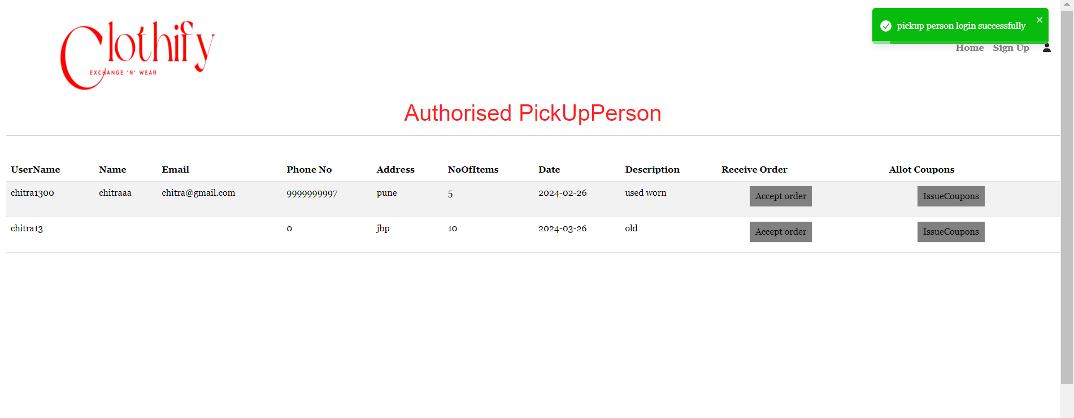

Allocate coupons page

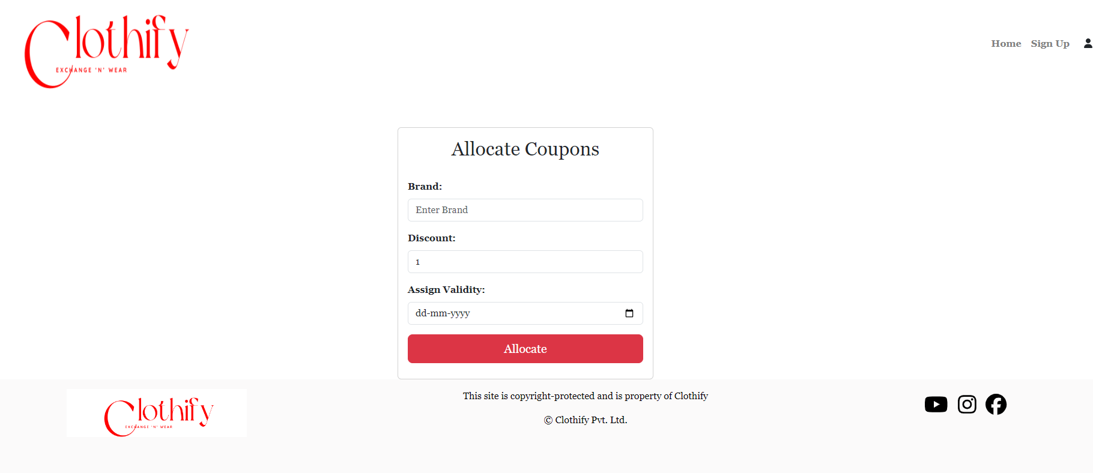

Admin Dashboard page

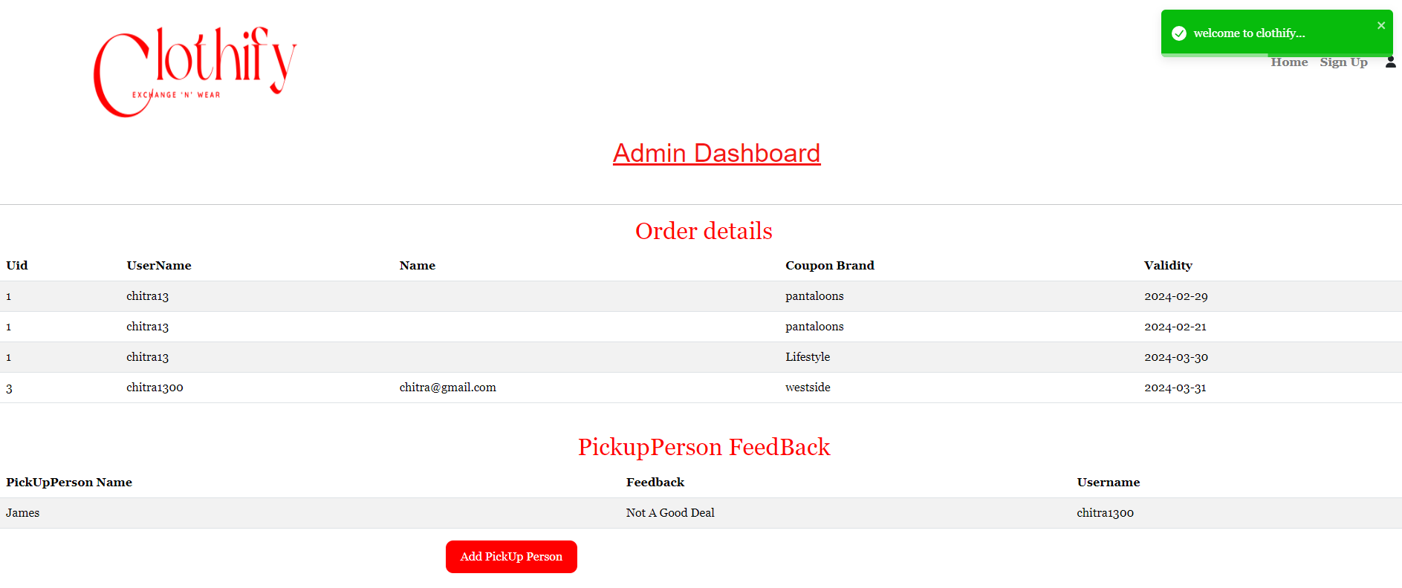

Feedback/Contact us page

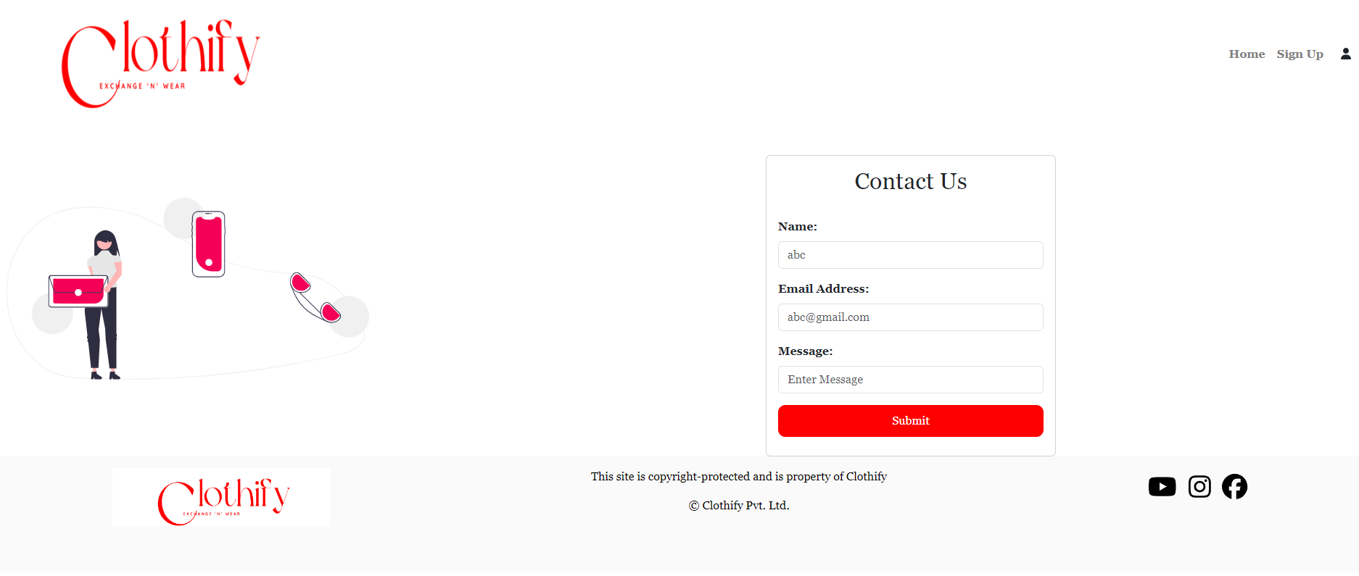

Pick Up person Feedback page

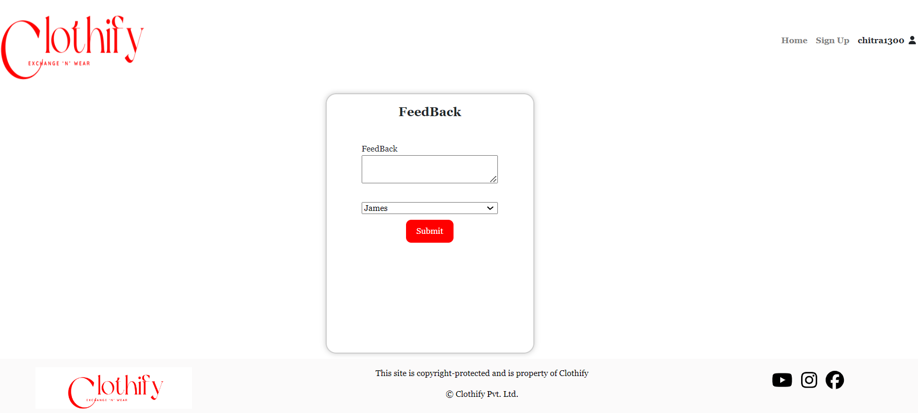

**8. References:**

Java: https://www.java.com/

Hibernate: https://hibernate.org/

React: https://react.dev/

MySQL: https://www.mysql.com/

Java Docs: https://docs.oracle.com/en/java/

React Docs: https://react.dev/